MOBILE PRICE PREDICATION USING

TENSOR FLOW

MINI REPORT

S.NO | TITLE |  | PAGE NO
 | Abstract |  | ii
1 | Introduction |  | 1
 | 1.1 | Machine Learning | 2
 | 1.2 | Python | 3
 | 1.3 | Mobile Details | 6
 | 1.4 | System Specification | 8
 | 1.5 | Tools Used | 8
2 | Literature Review |  | 9
3 | Machine Learning Process |  | 13
 | 3.1 | Data Collection | 14
 | 3.2 | Data Processing | 14
 | 3.3 | Model Training | 15
 | 3.4 | Model Evaluation | 16
 | 3.5 | Model Deployment | 16
 | 3.6 | Prediction | 16
4 | Proposed Method |  | 17
 | 4.1 | System Architecture | 18
 | 4.2 | Module 1 | 19
 | 4.3 | Module 2 | 20
5 | Result and Discussion |  | 21
6 | Conclusion |  | 29
6 | Reference |  | 30

ABSTRACT

ABSTRACT

This project develops a Mobile Price Prediction system using Recurrent Neural Networks (RNN) in TensorFlow to compare mobile prices across online platforms and retail shops. It analyses real-time pricing data, identifying trends and predicting future prices based on historical data. The system aims to differentiate between online and retail prices, providing insights into pricing variations. By utilizing RNN's ability to handle time-series data, the model forecasts price changes over time. Visualization tools like Seaborn and Matplotlib will help compare price trends, enabling consumers and businesses to make informed pricing decisions.

INTRODUCTION
CHAPTER 1

INTRODUCTION

The Mobile Price Prediction project leverages TensorFlow and Recurrent Neural Networks (RNNs) to analyse and predict the price variations of mobile devices across online and retail platforms. By analysing real-time data, the model identifies and compares price trends in different markets, allowing for accurate forecasting of mobile prices in both online and retail environments. This project aims to bridge the pricing gap between e- commerce and physical stores, providing valuable insights for consumers and retailers.

Machine Learning:

Machine Learning (ML) is a branch of artificial intelligence (AI) that focuses on enabling computers to learn from data and make predictions or decisions without being explicitly programmed. In ML, algorithms analyze and identify patterns within data, adapting and improving over time based on new data inputs. This allows systems to perform tasks such as classification, regression, clustering, and anomaly detection.

Machine Learning Process

      - Data Collection: Gathering data relevant to the problem you want to solve. This could be in the form of structured data (tables, CSV files) or unstructured data (images, text).
      - Data Preparation and Preprocessing: Cleaning and organizing data, handling missing values, normalizing or scaling features, and splitting the data into training and test sets. This step ensures data quality, which is crucial for accurate model predictions.
      - Feature Engineering: Selecting, extracting, or creating new features that help improve the model’s performance. This can include encoding categorical variables, generating new variables, or reducing dimensionality.
      - Model Selection: Choosing the appropriate ML algorithm or model type (e.g., linear regression, decision tree, neural network) based on the problem, data size, and structure. This step may involve trying out several models to find the best fit.
      - Model Training: Feeding the model with the training data so it can learn patterns and relationships within the data. This phase adjusts the model parameters to minimize error and improve accuracy.

      - Model Evaluation: Testing the model on unseen data (the test set) to evaluate its performance. Common metrics include accuracy, precision, recall, and F1 score, depending on the type of problem (classification or regression).
      - Hyperparameter Tuning: Fine-tuning the model’s hyperparameters (settings not learned from the data) to optimize performance. Techniques like grid search and random search are often used in this step.
      - Deployment: Deploying the trained model into a production environment where it can make predictions on new data in real-time or batch processing.
      - Monitoring and Maintenance: Continuously monitoring the model’s performance in the real world to ensure it remains accurate and relevant. Over time, retraining with new data may be necessary due to changing patterns or conditions.

Machine Learning Advantages:

      - Automation of Complex Tasks: ML enables automation of tasks that are too complex for traditional programming, such as image and speech recognition, natural language processing, and real-time fraud detection.
      - Improved Accuracy and Efficiency: ML algorithms learn from data and can improve their accuracy over time, leading to better decision-making and faster processing compared to manual methods.
      - Data-Driven Decision-Making: ML uses large amounts of data to identify patterns and trends, providing insights that allow for informed decision-making, often more quickly and accurately than human analysis alone.
      - Adaptability: ML models can adapt to new data and changing environments, making them useful in dynamic settings like stock market predictions, recommendation systems, and personalized marketing.

Python:

Python is a high-level, interpreted programming language known for its simplicity, readability, and versatility. Created by Guido van Rossum and first released in 1991, Python has become one of the most popular programming languages due to its ease of use and broad applicability across domains.

Key Features of Python:

      - Easy to Learn and Use: Python’s syntax is straightforward and clean, making it an excellent choice for beginners while still being powerful enough for experienced developers.
      - Interpreted Language: Python code is executed line-by-line by an interpreter, which simplifies debugging and development since there’s no need to compile code before running it.
      - Dynamic Typing: Variables in Python don’t require explicit type definitions, as the language infers data types automatically, making code more flexible and concise.
      - Object-Oriented and Functional: Python supports object-oriented programming (OOP) and functional programming, enabling developers to use classes, inheritance, and polymorphism alongside functions and higher-order operations.
      - Extensive Libraries and Frameworks: Python has a vast ecosystem of libraries and frameworks, such as Pandas, NumPy, TensorFlow, Django, Flask, and Matplotlib, making it easy to implement complex functionalities.
      - Cross-Platform: Python code can run on multiple platforms, including Windows, macOS, and Linux, with little or no modification.
      - Strong Community Support: Python’s large and active community provides extensive documentation, tutorials, and support, contributing to its vast open-source library ecosystem.

Packages:

Pandas:
Pandas is a powerful data manipulation and analysis library in Python. It provides data structures like Data Frames, which make it easy to handle and process structured data. In this project, Pandas is used for data cleaning, filtering, and organizing price data collected from various sources, making it essential for preparing data for machine learning models.

NumPy:

NumPy is a foundational library for numerical computing in Python, providing support for arrays, matrices, and a wide range of mathematical functions. It is particularly useful for data preprocessing and manipulation of numerical data. In this project, NumPy assists with mathematical operations and data transformations, especially when dealing with large datasets.

Matplotlib/Seaborn:

Matplotlib is a plotting library for creating static, animated, and interactive visualizations in Python. Seaborn, built on top of Matplotlib, provides a high- level interface for creating attractive statistical graphics. Together, these libraries help visualize mobile price trends, comparisons, and predictions, making the data insights easy to interpret.

TensorFlow:

TensorFlow is an open-source machine learning framework that simplifies building and deploying neural networks. It provides the tools for developing and training machine learning models, like Recurrent Neural Networks (RNNs), to handle sequential data. TensorFlow is crucial in this project for constructing and training the model that predicts mobile prices based on real- time data.

Recurrent Neural Network (RNN):

RNN is a type of neural network well-suited for sequential data, such as time series or natural language processing. Unlike other neural networks, RNNs maintain a memory of previous inputs, which allows them to learn from temporal dependencies. In this project, an RNN model analyses historical price

data to predict future mobile prices, providing insights into market trends across online and retail environments.

Mobiles Details

    - History of Android

      - Founding of Android Inc. (2003): Android Inc. was created to develop an advanced operating system, initially for cameras but later shifted focus to mobile devices.
      - Google Acquires Android (2005): Google acquired Android Inc. with plans to create an open-source mobile OS, aiming to compete with Symbian and Windows Mobile.
      - First Android Device – HTC Dream (2008): The HTC Dream (T-Mobile G1) was the first Android smartphone, featuring a physical keyboard and introducing the Android Market for app downloads.
      - Early Android Versions: Releases like Cupcake, Donut, and Eclair introduced critical features, including on-screen keyboards, widgets, and Google Maps Navigation.
      - Tablet-Specific Android (2011): Honeycomb (Android 3.0) was the first version tailored for tablets, featuring an interface optimized for larger screens.
      - Material Design (2014): Android Lollipop (5.0) introduced Material Design, giving Android a unified, sleek look that modernized its UI across devices.
      - Growing Market Dominance (2015): Android KitKat and Lollipop expanded Android's accessibility across devices and price ranges, making it the leading mobile OS globally.
      - Enhanced Security and Performance: Versions like Marshmallow, Nougat, and Oreo improved app permissions, security updates, and system performance, establishing Android as a robust platform.
      - Shift to Numerical Naming (2019): Starting with Android 10, Google switched from dessert names to numeric naming for simplicity, introducing system-wide dark mode and privacy enhancements.

      - Continued Innovation (2020-Present): Android 11, 12, and beyond brought advancements like customizable UI (Material You), 5G support, and improved privacy features, cementing Android's adaptability and relevance.

Mobile Architecture:
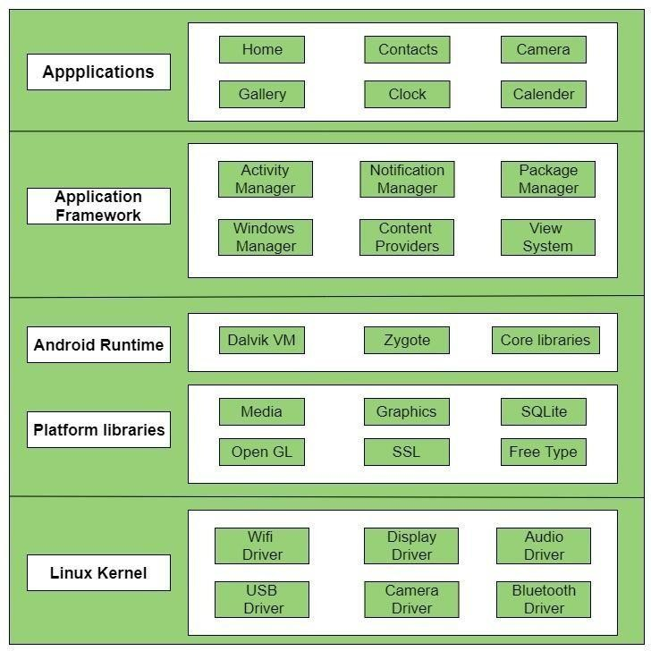

Fig 1: The Architecture of the Android Mobile

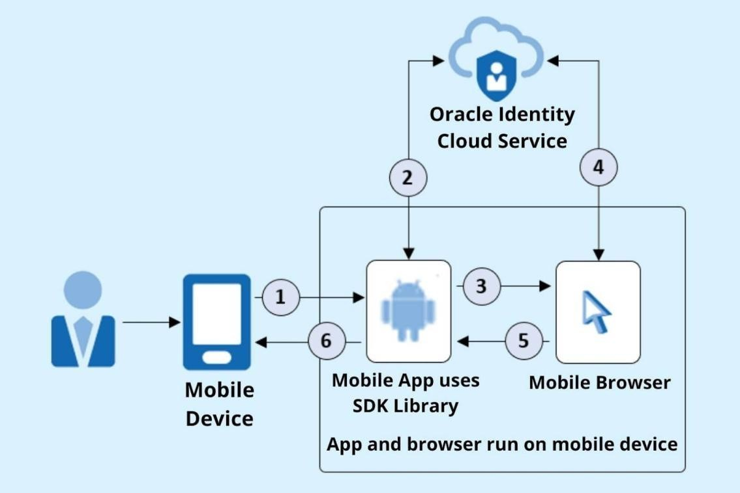

Fig 2: App and Browser run on mobile device

SYSTEM SPECIFICATION:

Process : Intel Core i5

Hard Disk : 512 Gb

RAM : 8 GB

Operating System : Windows 11

TOOLES USED:

IDE : PyCharm IDE

Programming Languages : Python

Packages : NumPy, Pandas, Matplotlib/seaborn, TensorFlow, RNN.

LITERATURE REVIEW
CHAPTER 2
- LITERATURE REVIEW

- I used different Machine Learning models and found Xgboost and Logistic Regression gave the best testing accuracy after manipulating and testing different parameters. Xgboost gave 95.1% testing accuracy and Logistic Regression gave 96.7% testing accuracy.

- Mobile phones come in various price ranges and specifications. Accurate price prediction is essential for effective consumer strategy and market success. This project focuses on building a machine learning model that predicts the price range of mobile phones based on their features.
  - Methodology
    - Data Analysis: Examine data using statistical methods to identify meaningful information.
    - Data Preprocessing: Clean the data, handle missing values, and convert non-numeric data into numerical format using one-hot encoding.
    - Model Building: Train classification algorithms (Random Forest, Gaussian NB, KNN, SVM) on the preprocessed data.
    - Model Evaluation: Evaluate the models' accuracy using confusion matrices and other metrics.

- In this Blog we are going to do implementing a salable model for predicting the mobile price prediction using some of the regression techniques based of some of features in the dataset which is called mobile Price Prediction. There are some of the processing techniques for creating a model. In this project i used web scrapping techniques for collecting the mobile data from E-Commerce website.

  - Algorithms used
The major aim of in this project is to predict the house prices based on the features using some of the regression techniques and algorithms.
    - Random Forest Regressor
    - Support Vector Regressor
- Stock Price Prediction project using TensorFlow. Stock Market price analysis is a Timeseries approach and can be performed using a Recurrent Neural Network. To implement this we shall Tensorflow. Tensorflow is an open-source Python framework, famously known for its Deep Learning and Machine Learning functionalities. Building Neural Networks becomes easy by writing just a few lines of Tensorflow code.
- Creating a model to predict mobile price based on the characteristics. I'll be using TensorFlow keras to do deep neural network. Deep neural network represents the type of machine learning when the system uses many layers of nodes to derive high- level functions from input information. It means transforming the data into a more creative and abstract component. This model is expected could facilitate a company to decide what price mobile phone belongs to their characteristics. So the price is relevance compared to the other company

- Built using TensorFlow, this ANN model predicts mobile phone prices based on features. It includes two hidden layers (8 and 4 neurons). The dataset is split 75/25 for training/testing, trained for 100 epochs with a batch size of 32, and the weights are saved for future use.

- To predict the mobile price on the basis of the given features in our dataset by using data visualization, preprocessing, classification models using Tensorflow.

- Mobile price classification is explored through machine learning, focusing on predicting mobile prices based on parameters like memory and weight. Various

- models, including logistic regression and support vector machines, are tested for accuracy, with logistic regression achieving the highest accuracy of 95.5%. The model is further optimized, reaching a 97% accuracy.

- mobile price range prediction using machine learning outlines the methodology, objectives, and results. The model utilizes data collection, preprocessing, and algorithms like KNN and linear regression to predict prices. Key features impacting prices were identified, with KNN achieving the highest accuracy of 92.121%. Future improvements and applications were discussed.

- Mobile price classification is demonstrated using various machine learning algorithms. The project predicts mobile price ranges based on features like camera quality, battery capacity, and internal memory. After implementing different models, logistic regression achieved the highest accuracy.

- A mobile price prediction model is being developed using machine learning to analyze various phone specifications and their market prices. The process includes exploratory data analysis, univariate and multivariate analysis, and training the model with datasets. The ultimate goal is to accurately predict mobile prices based on features like RAM, camera, and battery power.

- A linear regression model is used to predict mobile prices using a dataset with 160 rows and 14 columns. The script demonstrates data preparation, model training, and prediction comparison, showing minimal differences between actual and predicted values, indicating the model's accuracy in price prediction.

MACHINE LEARNING PROCESS
CHAPTER 3

MACHINE LEARNING PROCESS:

- DATA COLLECTION
- DATA PROCESSING
- MODEL TRAINING
- MODEL EVALUATION
- MODEL DEPLOYMENT
- PREDICTION

DATA COLLECTION:

    - Gather real-time mobile price data from online sources (e.g., e-commerce websites) and retail shops.
    - Organize the collected data into structured formats like CSV or databases to facilitate easy access and manipulation
    - Number of Rows and columns in the Data set 163 rows and 5 columns
      - The Data set Attributes:
        - Brand
        - ROM
        - RAM
        - Online-Price
        - Retail-Price

DATA PROCESSING:

    - Clean and preprocess the data using Pandas, handling missing values, duplicates, and irrelevant information.
    - Normalize or scale data to improve model performance and reduce potential biases in price comparisons.
    - Convert categorical data (e.g., brand or model) into numerical values and structure time-based data for RNN training

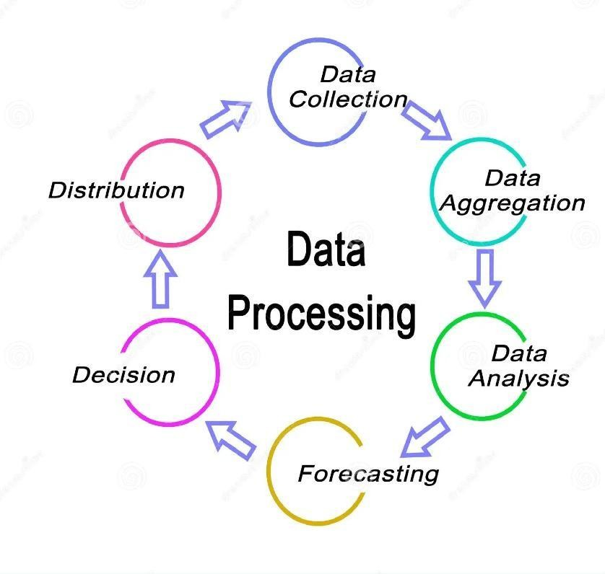

Fig 3.1 : Data Processing Diagram

MODEL TRAINING:

    - Use TensorFlow to build a Recurrent Neural Network (RNN) model, designed to handle sequential data like time series.
    - Train the model on historical mobile prices to learn patterns and trends over time.
    - Adjust hyperparameters (e.g., learning rate, epochs) to optimize the model's ability to predict future prices accurately.

3.3.1 RNN Architecture:

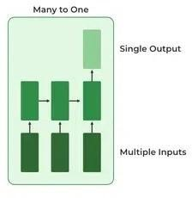

Fig 3.2: RNN Many to One

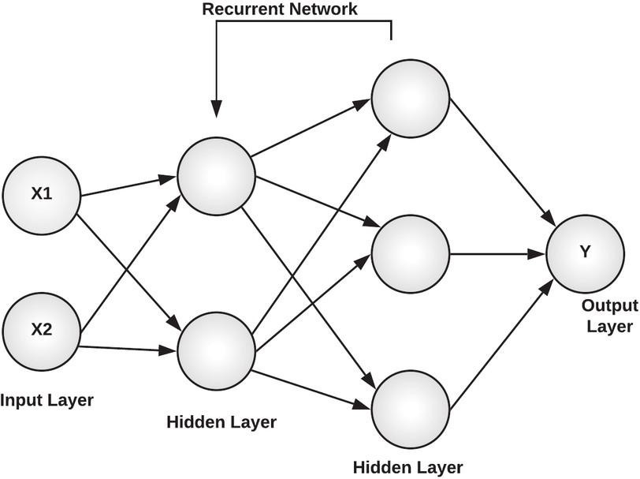

Fig 3.3: RNN Architecture

MODEL EVALUATION:

    - Evaluate the model's accuracy and effectiveness using metrics like Mean Absolute Error (MAE) or Root Mean Square Error (RMSE).
    - Test the model on a validation dataset to assess its prediction performance for unseen data.
    - Perform fine-tuning and adjustments based on evaluation results to improve prediction accuracy.

MODEL DEPLOYMENT:

    - Deploy the trained model on a suitable platform, such as a web server or cloud service, for easy access and scalability.
    - Set up automated retraining pipelines to incorporate new data periodically, keeping the model up-to-date with market trends.

PREDICTION:

    - Use the deployed model to predict mobile prices across online and retail channels based on recent market data.
    - Provide a comparison between predicted prices for online stores and retail outlets, highlighting potential price differences.
    - Display the predictions and trends visually, helping users make informed purchasing decisions by comparing price trends.

‘

PROPOSED METHOD
CHAPTER 4

PROPOSED METHOD

  - SYSTEM ARCHITECTURE

Mobile Dataset Collection

Data Preprocessing

Model Training (RNN)

Model Evaluation

Analysis of Data

Model Deployment
Visualization of data(Accuracy)

MODULE 1

    - Dataset Description

    - Data Preprocessing

    - Model

Dataset Description

      - The main Objective of using this dataset is to predict the mobile prices in Online and Retail-shop to measure the price difference
      - In this data taken from the Amazon websites and Poorvika Mobiles websites. This data set contain 10 sample data out of 163 datas

Dataset Preprocessing

      - Data Collection

Gathering relevant data on mobile phone specifications and prices from online and retail sources.

      - Data Preprocessing

Cleaning and transforming the data to prepare it for model training

Data Integration
Data Cleaning
Data
Transformation
Data Reduction or Dimension

Fig 4.1 : Data Preprocessing


Dataset Collection

Feature Scaling

Data Partition

Fig 4.2 : Use Case Diagram
Customer
Name
Requirements

Online Price
Retail Price
Mobile

Purchased

Fig 4.3: ER Diagram

Age

Location
Customer

    - Model

      - Model Training

Building and training a Recurrent Neural Network model using TensorFlow to learn the relationships between features and prices.
      - Model Evaluation

Evaluating the model's performance on unseen data to assess its accuracy and reliability.
      - Model Deployment

Deploying the trained model for real-time price predictions.

MODULE 2:

    - Recurrent Neural Network

Recurrent Neural Network

      - Input Layer

Processes the preprocessed data, including features like brand, RAM, storage
      - Hidden Layers

Extract complex patterns and relationships within the data using recurrent units, capturing temporal dependencies
      - Output Layer

Predicts the mobile phone price based on the learned patterns.

Recurrent Network
X1
Y
Output Layer
X2
Input
Hidden Layer

Hidden Layer

Fig 4.3: RNN Architecture

RESULT and DISCUSSION
CHAPTER 5

RESULT and DISCUSSION

The diagram is a Histogram with KDE (Kernel Density Estimate) overlay. It represents the distribution of RAM sizes (in GB) across a dataset, showing both frequency (as bars) and the probability density

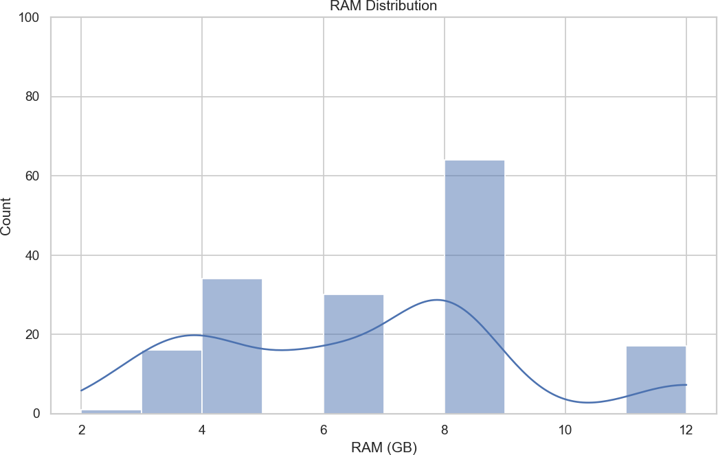
The diagram is a Histogram with KDE (Kernel Density Estimate) overlay. It shows the distribution of ROM sizes (in GB), where the bars represent frequency and the curve represents the probability density of ROM values.
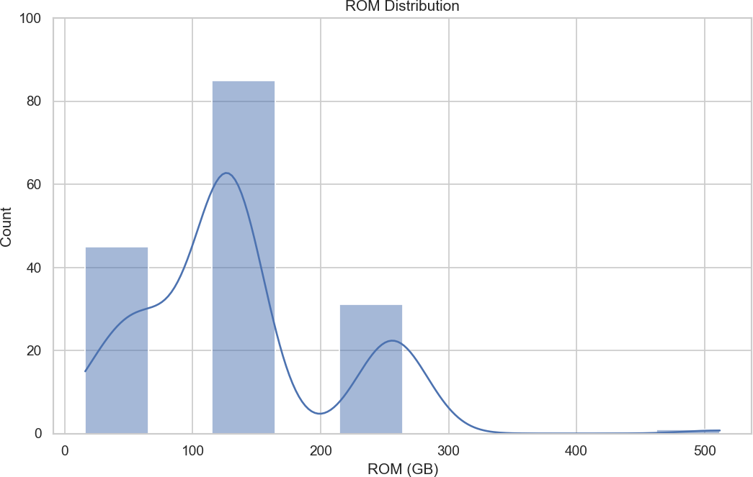

The diagram is a Scatter Plot. It illustrates the relationship between RAM (in GB) and ROM (in GB), where each point represents a data pair, helping to identify trends or correlations between the two variables.
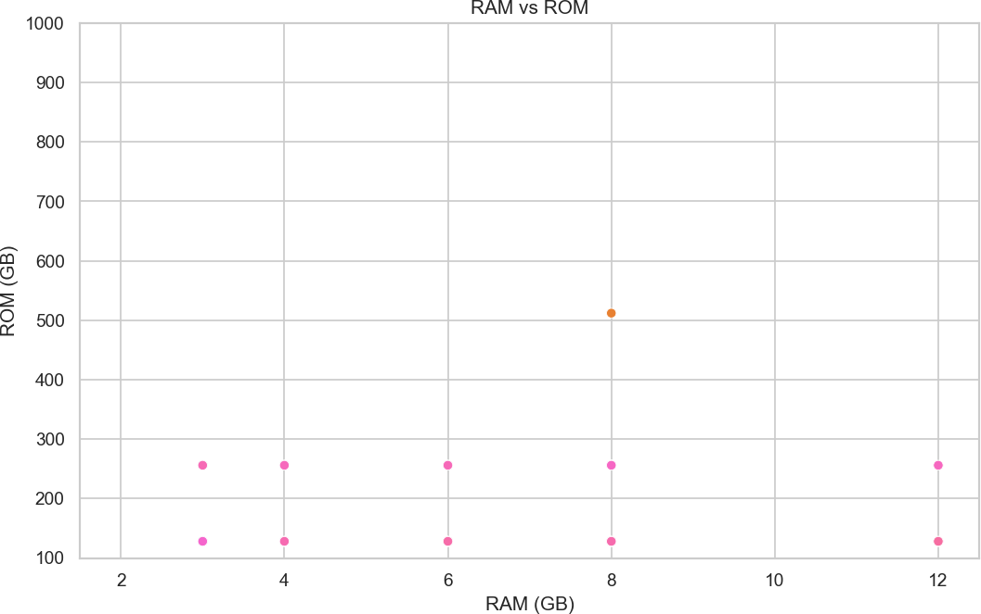

The diagram shown in the image is a Horizontal Bar Chart. It is used to compare categories (in this case, different OnePlus phone models) based on a numerical value (here, average RAM in GB). Each bar's length represents the corresponding value, making it easy to visually compare the data.

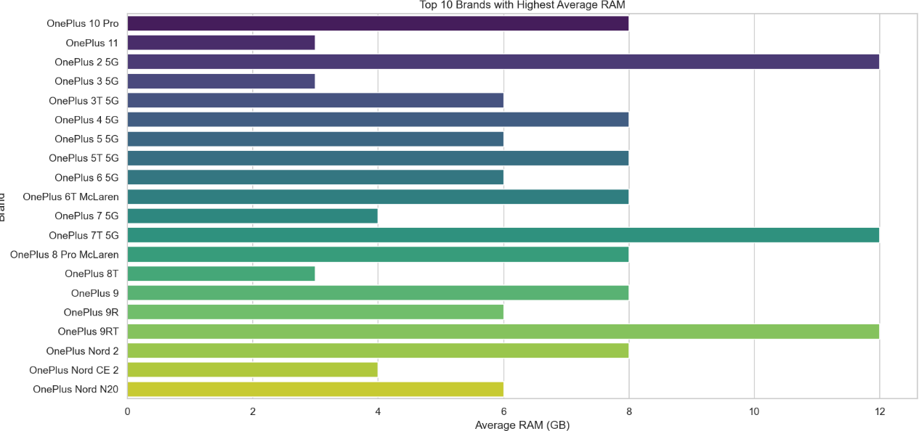

The output shown is not a diagram but a training log from a machine learning model. It represents the progress of training over multiple epochs, displaying metrics such as time per step and loss at each epoch. The loss value indicates how well the model is performing; lower values generally mean better performance
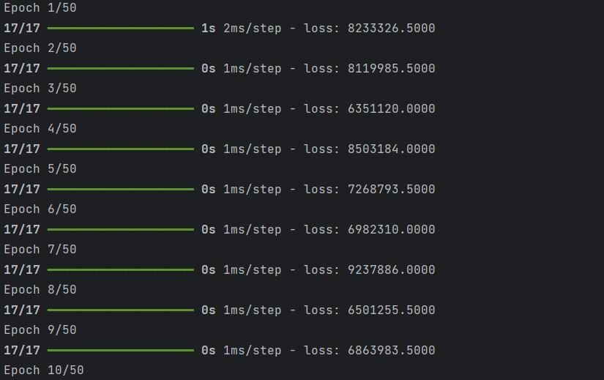

The diagram shown is a Line Chart. It compares the actual price difference (blue line) and the predicted price difference (red line) across multiple samples, showcasing how well the predictions match the actual values over the given index range.

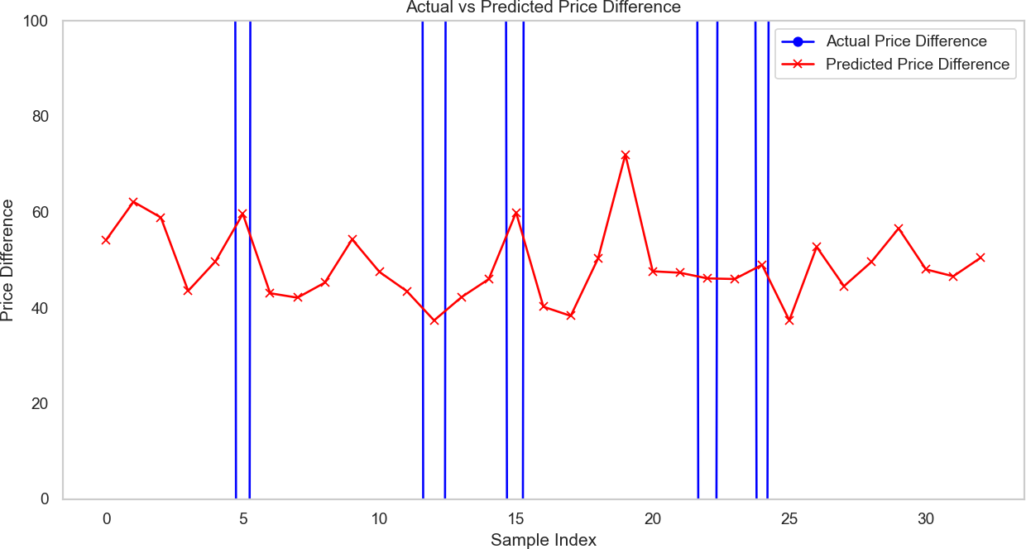

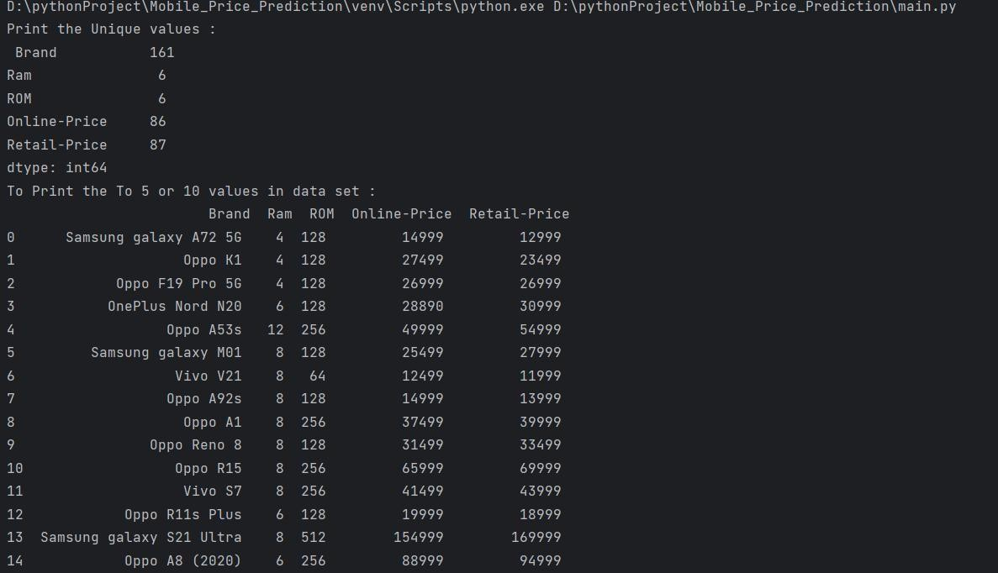

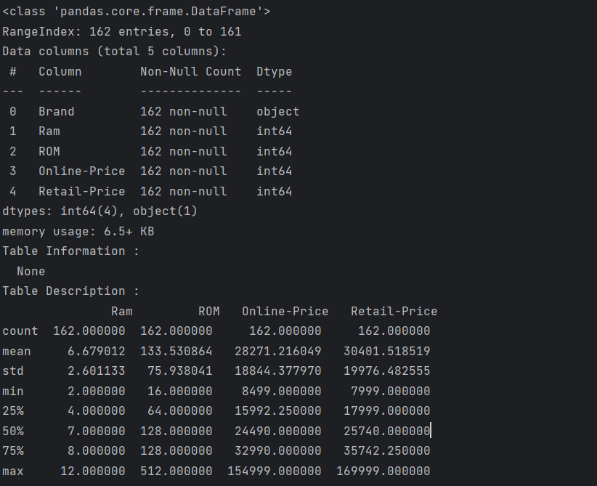
Retail-Price and Online-Price
50000
45000
40000
35000
30000
25000
20000
15000
10000
5000
0
Samsung
Vivo
Oppo
OnePlus
Online-PriceRetail-Price

RAM and ROM
10
9
8
7
6
5
4
3
2
1
0
Samsung
Vivo
Oppo
OnePlus
RAMROM

APPENDIX:
RAM and ROM and Online-Price and Retail-Price
10
9
8
7
6
5
4
3
2
1
0
Samsung
Vivo
Oppo
OnePlus
RAMROMOnline-PriceRetail-Price

CODING:

import matplotlib.pyplot as plt import plotly.express as px import matplotlib.patches as mplt import numpy as nm
import numpy as np import pandas as pd import seaborn as sea
from sklearn.compose import ColumnTransformer from sklearn.ensemble import RandomForestClassifier from sklearn.neighbors import KNeighborsClassifier from sklearn.neural_network import MLPRegressor
from sklearn.preprocessing import StandardScaler, OneHotEncoder from sklearn.model_selection import GridSearchCV
from sklearn.model_selection import GridSearchCV from sklearn.model_selection import train_test_split from sklearn.preprocessing import MinMaxScaler from tensorflow.keras.models import Sequential
from tensorflow.keras.layers import Dense,SimpleRNN from tensorflow.keras.layers import Dropout, LSTM import tensorflow as tf

from sklearn.pipeline import Pipeline
from sklearn.neighbors import KNeighborsClassifier
from sklearn.metrics import accuracy_score, mean_squared_error, r2_score, confusion_matrix import os
os.environ['TF_ENABLE_ONEDNN_OPTS'] = '0' df=pd.read_csv(r'PhoneModel1.csv')
#print the unique values
print("Print the Unique values : \n",df.nunique())

#Print the Table valued
print("To Print the To 5 or 10 values in data set : \n",df.head(15)) # sea.countplot(df['Ram'])
#print the table Information print("Table Information :\n ",df.info())

#Print Description of the datas
print("Table Description : \n",df.describe())

# df.plot(x='Ram', y='Brand', kind='scatter') # plt.show()

# Visualize data sea.set(style="whitegrid")

# 1. Distribution of RAM plt.figure(figsize=(10, 6)) sea.histplot(df['Ram'], kde=True, bins=10) plt.title('RAM Distribution') plt.xlabel('RAM (GB)')
plt.ylabel('Count') plt.ylim(0, 100) plt.show()

# 2. Distribution of ROM plt.figure(figsize=(10, 6)) sea.histplot(df['ROM'], kde=True, bins=10) plt.title('ROM Distribution') plt.xlabel('ROM (GB)')
plt.ylabel('Count') plt.ylim(0, 100) plt.show()

# 3. Scatter plot of RAM vs ROM plt.figure(figsize=(10, 6))
sea.scatterplot(x='Ram', y='ROM', hue='Brand', data=df, legend=False) plt.title('RAM vs ROM')
plt.xlabel('RAM (GB)')
plt.ylabel('ROM (GB)')

plt.ylim(100, 1000) plt.show()

# 4. Bar plot of brands with most RAM
# 4. Bar plot of brands with most RAM (corrected for future seaborn versions)

# Updated Bar plot of brands with most RAM (y-axis is Brand and x-axis is RAM) plt.figure(figsize=(12, 6))
top_brands = df.groupby('Brand')['Ram'].mean().head(20)

sea.barplot(x=top_brands.values, y=top_brands.index, hue=top_brands.index, palette='viridis', dodge=False, legend=False)
plt.title('Top 10 Brands with Highest Average RAM') plt.xlabel('Average RAM (GB)')
plt.ylabel('Brand') plt.show()

# Sample data for phone print("Statistical Summary:") print(df.describe())

# 2. Correlation between Online and Retail Prices correlation = df['Online-Price'].corr(df['Retail-Price'])
print(f"\nCorrelation between Online and Retail Price: {correlation:.2f}")

# 5. Difference between Online and Retail Prices
df['Price-Difference'] = df['Retail-Price'] - df['Online-Price']

# 6. Histogram of Price Differences plt.figure(figsize=(10, 6))
plt.hist(df['Price-Difference'], bins=30, color='skyblue', edgecolor='black') plt.title('Histogram of Price Differences (Retail - Online)') plt.xlabel('Price Difference')
plt.ylabel('Frequency') plt.ylim(0,100) plt.show()

# 7. Brands with Maximum Price Difference
max_diff_brands = df[df['Price-Difference'] == df['Price-Difference'].max()] print("\nBrand with Maximum Price Difference:") print(max_diff_brands[['Brand', 'Price-Difference']])

#RNN
df['Price-Difference'] = df['Retail-Price'] - df['Online-Price'] # Select features and target variable
X = df[['Ram', 'ROM', 'Online-Price']].values y = df['Price-Difference'].values

# Normalize the features scaler = StandardScaler() X = scaler.fit_transform(X)

# Reshape input to be 3D [samples, time steps, features] X = X.reshape(X.shape[0], 1, X.shape[1])

# Split the data into training and testing sets
X_train, X_test, y_train, y_test = train_test_split(X, y, test_size=0.2, random_state=42)

# Define the RNN model model = Sequential()
model.add(SimpleRNN(50, activation='relu', input_shape=(X_train.shape[1], X_train.shape[2]))) model.add(Dense(1)) # Output layer for regression

# Compile the model
model.compile(optimizer='adam', loss='mean_squared_error')

# Train the model
model.fit(X_train, y_train, epochs=50, batch_size=8, verbose=1)

# Make predictions
y_pred = model.predict(X_test)

# Generate the chart to compare actual vs predicted plt.figure(figsize=(12, 6))
plt.plot(y_test, marker='o', label='Actual Price Difference', color='blue') plt.plot(y_pred, marker='x', label='Predicted Price Difference', color='red') plt.title('Actual vs Predicted Price Difference')
plt.xlabel('Sample Index') plt.ylabel('Price Difference')

plt.ylim(0, 100) plt.legend() plt.grid() plt.show()

CONCLUSION
CHAPTER 6

CONCLUSION

Future enhancements for the mobile price prediction model include incorporating additional data sources such as user reviews, customer ratings, and social media sentiment. These features could provide deeper insights into market dynamics and consumer preferences, thereby refining the model's prediction accuracy. The current model has already demonstrated a high level of accuracy in forecasting mobile phone prices, showcasing its effectiveness in capturing complex pricing patterns and its potential as a reliable tool for price analysis across various platforms.

REFERENCE:

- Deep Matrix channel in YouTube

https://youtu.be/iGtiNEgsL0A?si=u2qjx9N1Hh0TxumJ

Refer the Some projects

https://www.geeksforgeeks.org/stock-price-prediction-project-using-
tensorflow/

Smart-Phone-Price-Prediction in kshitij1210 GitHub account

https://github.com/kshitij1210/Smart-Phone-Price-Prediction

Mobile-Price-Classification in Hafeez -Ur Rehman

https://github.com/Hafeez-UrRehman/Mobile-Price-Classification

Shanmuga Mobile Price Prediction

https://github.com/Sanmuga/Mobile-price-prediction

Mobile Price Prediction Using Machine Learning
https://medium.com/@Nivitus./mobile-price-prediction-using-machine- learning-fa9cab6fb242

Data Science Tutorial YouTube Chennel
https://www.youtube.com/watch?v=mLz_Q7L95C8&t=89s

Gabriel Atkin YouTube Chennel
https://www.youtube.com/watch?v=Ocxufeylg9M&t=4s

ANN-Model-for-Mobile-Price-Prediction
https://github.com/SE-LAPS/ANN-Model-for-Mobile-Price-Prediction

